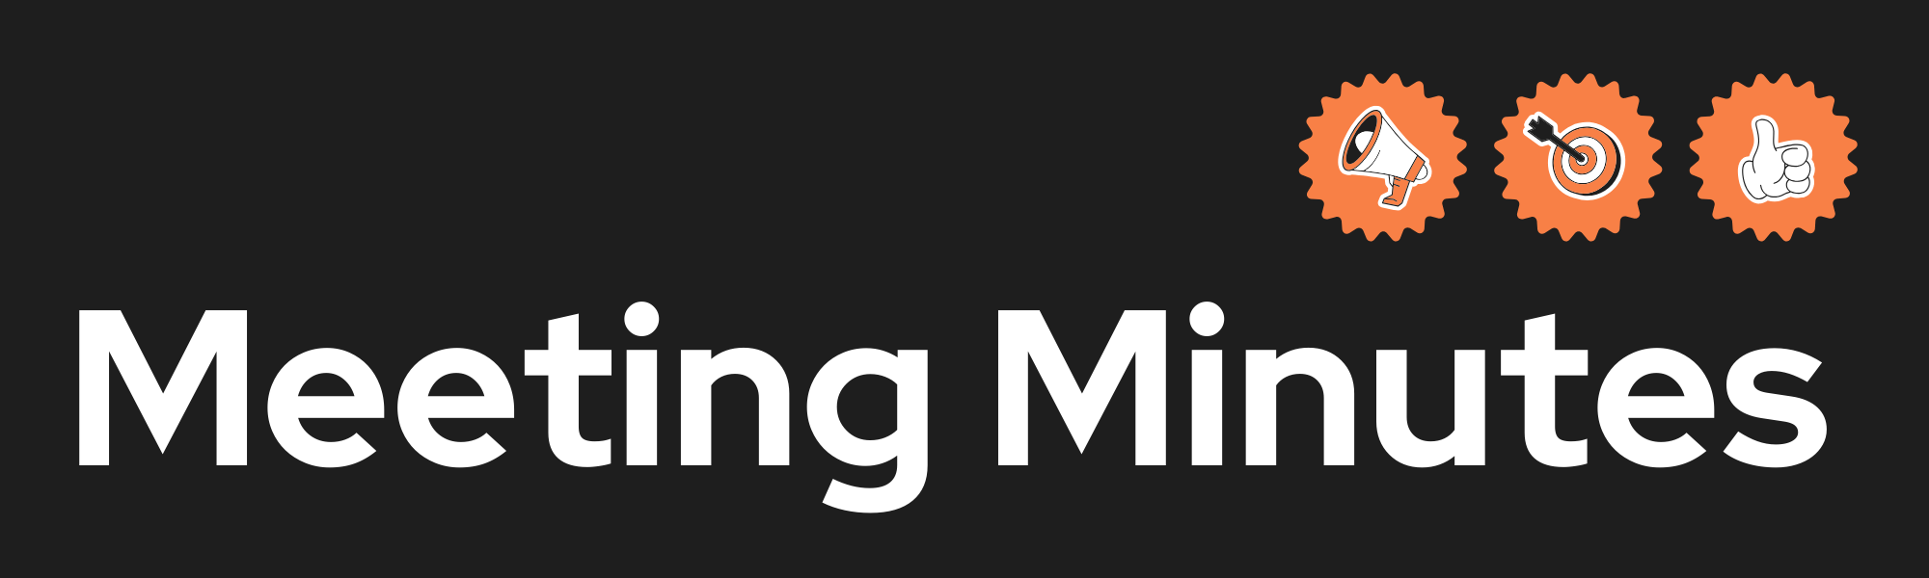
Date and Time | Sunday 8th 2026 13:00pm
Project Name | Study Buddy
Meeting Goal | - Agreed on a code of conduct  - Agreed on a group name: Study Buddy  - Chosen a project
Facilitator | Erik and Musa
Note taker | Erik
Attendees | Musa  Erik  Asha  Bashir
Roundtable Updates (each group member to contribute) | Musa created the repositories and scaffolding  Erik created the project description and code of conduct  Asha filled in the meeting sheet also checked over commitments being committed  Bashir double checked everything, and he came up with the issues that later helped us sort out how we would move with our project
Discussion points | Ethical issues  Code of conduct  Personas  Project idea and name  Kanan board  Scaffolding
Actions (list tasks and assign a group member) | Erik: project admin  Musa: initiator and coder  Asha: admin overlooker  Bashir: double checker and problem seeker

